Adult Social Care Travel Assistance Survey

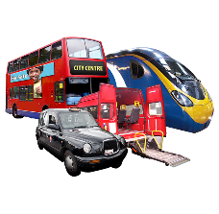
Buckinghamshire Council are writing an Adult Social Care Travel Assistance Policy.

We are talking to the people who provide your transport.

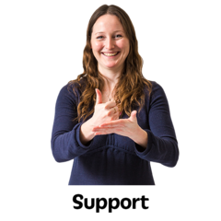
We want to make sure this policy is consistent and fair, to support people who have social care needs.

Information about your experiences will help us to write this policy.

People you can ask to help you complete this survey:

- A family member
- A friend
- Someone at your day service
Q1. How were your transport needs discussed at your Better Lives care assessment?

☐ With a social worker as part of the assessment

☐ With a social worker after the assessment

☐ My transport needs were not discussed

☐ I don’t have any transport needs (go to Question 3)

Other - please write here:
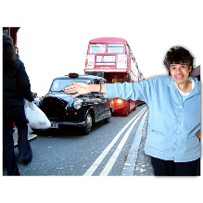
Q2. How confident were you about the flexibility of travel assistance offered?

Did it support your needs?
Did it improve your independence?
Did it meet your Better Lives outcomes?

☐ Very confident

☐ Confident

☐ OK

☐ Unsure

☐ Not confident

☐ I did not receive any offer of travel assistance

If you have answered unsure or not confident, can you please tell us why:

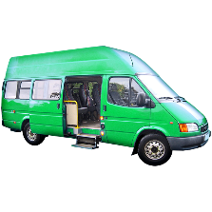
Q3. Do you travel in a taxi, mini-bus or other vehicle provided by Buckinghamshire Council?

☐ Yes ☐ No

If you ticked Yes, how would you rate this service? (please circle or highlight 1 option below)

1 – Very Good

2 – Good

3 – OK

4 – Poor

5 – Very Poor

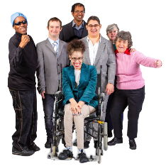
Q4. Do you normally travel to a day service or activity in the community?

☐ Yes ☐ No

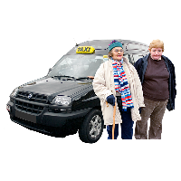
Q5. Do you travel with another person from your day service or activity?

☐ Yes ☐ No

If you ticked No, would you like to travel with another person who attends the same day service?

☐ Yes ☐ No

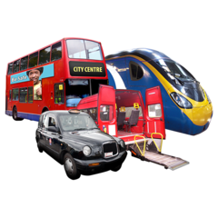
Q6. How do you get to your day service, or activity in the community?

☐ Taxi, mini-bus or other vehicle provided by the Council

☐ Private transport paid for by the Council (e.g. a taxi paid from your direct payment, or mileage payment)

☐ Private transport (not paid for by the Council)

☐ Public Transport (e.g. bus or train)

☐ Motability Vehicle

☐ A relative, friend or carer takes me by car

☐ Walk

☐ Other

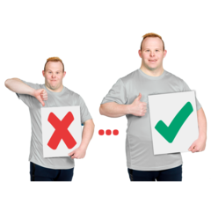
Q7. If you travel by council transport, do you think we could make it better?
e.g.
Training for drivers
ID badges
Driver’s behaviour
Knowing who to talk to about your transport

☐ Yes ☐ No

If you ticked yes, please tell us how we could make it better:

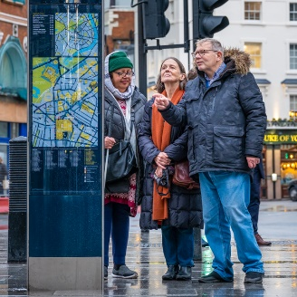
Q8. Have you had or have you been offered any independent travel training?

☐ Yes, by the council
☐ Yes, by another provider
☐ No, but I would be interested
☐ I would not be able to do travel training due to my needs
☐ No

Other? Please tell us here:

Q9. If your assessment found that independent travel training could be offered, which of the following would you like? (Tick as many boxes as you like, no limit).

Training with your chosen family member |  | Access to technology to help you.  e.g.  GPS tracker  Speaking clock |  | Option to use your direct payment budget for this training
Your needs and goals assessed before training |  | Personalised training just for you |  | Small group training with people like you
Training by your day service provider |  | Training by the council

If you have other ideas, please tell us here:

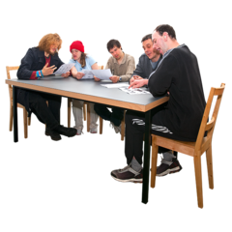
Q10. The Council is writing a Travel Assistance Policy to share with you. It is about how decisions are made about your transport and what services there are for you.

What do you think are the most important things that the Travel Assistance Policy should include? (Tick as many boxes as you like, no limit).

Easy Read |  | Equality - that everyone is treated the same |  | You understand what you are entitled to
The Policy follows the rules in the Care Act 2014 |  | The council’s funding is spent correctly |  | Your independence and wellbeing are a priority
You understand what transport the council is required to provide for you |  | Gives you a chance to discuss your travel options |  | Makes sure that best practice and standards are maintained
Stops other people making false claims |  | Policy has been made with residents like you and local charities |  | Clear appeal process for you or your family
Question and answer sheet to answer questions you or others may have |  | Fact sheet for you and your family about transport (instead of a question & answer sheet) |  | Your social worker can talk to a transport group to discuss your options or any problems

If you have other ideas, please tell us here:

Q11. Do you need the Policy in another format? This may help you to read it easily and understand what it says.

No |  | Audible version |  | Braille
Easy Read |  | Large print |  | Printed if you have no computer access
Other language? Please tell us which language:

About you?

It would be useful for us to know who has completed this survey
This is to make sure that we have looked at the needs of as many of our residents as possible.
You do not need to tell us your name or any personal details.

What is your age?
- 18-24
- 25-34
- 35-44
- 45-54
- 55-64
- 65+

What is your ethnic group?
Choose one that best describes you.

☐ White
☐ Black / African / Caribbean / Black British
☐ Mixed / Multiple
☐ Other
☐ Asian / Asian British

Please write your postcode in this box

Thank you for your time. Your feedback will make a difference. It will help us improve our services for you and other Buckinghamshire residents.

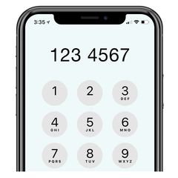
Do you need help completing this survey?
Would you like it in another format?
Do you have any questions?

Please contact: Jacqueline.Galvin@buckinghamshire.gov.uk
Or call Jacqueline on 01296 674600

Personalisation Team - Adults and Health Directorate, Buckinghamshire Council

